A Case Study of an Independent Chinese Secondary School in Kuala Lumpur, Malaysia:
Teacher Appraisal and Feedback

DENG FANG LING, Mogana Dhamotharan

SEGi University, Malaysia.

Abstract

Purpose: Malaysia is known for its comprehensive Chinese language education system. The school of this study is renowned for its high academic performance and high student enrolment numbers. This case study tries to describe a comprehensive picture of teachers’ appraisal and assessment in such a successful school, the strength and shortcomings could be a reference to the other similar kind of Independent Chinese Secondary Schools (ICSSs).
Design and Methods: Mixed methods research and the explanatory research design were employed. A total of 118 Teachers and 18 teachers were convenient sampled for the quantitative and qualitative data.
Findings: Teachers play various roles in a school so that the multiple layer assessment was employed for teacher appraisal work in the school. The annual teacher appraisal done internally by the school had little impact on job satisfaction and self-efficacy.
Originality: Existing literature on the Chinese language system of education in Malaysia approaches it from various angles of teaching methodology, curriculum, learning motivation, classroom environment and historical underpinnings. There is a dearth of knowledge on teacher appraisal of these successful schools and this case study attempts to address this gap in knowledge by applying a comprehensive and in-depth mixed research design.

Keywords: Case Study; High Performing Vernacular School; Independent Chinese Secondary School; Mixed Methods Research; Teacher Appraisal and Feedback

1. Introduction
1.1 Background of the study
Malaysia is known for its comprehensive Chinese language education system and it is the only country in the world, which has the whole Mandarin education system from primary school to university level besides China, Hong Kong and Taiwan. Since as early as 414 A.D. the Chinese had made contact with the Malay Archipelago (known to the Chinese as Nanyang) and the first significant Chinese settlements could be dated from the thirteenth-century (Comber, 1983, p. 1). The early known contacts with the Malay Archipelago probably occurred during the Ming Dynasty, when the Chinese eunuch, Admiral Cheng Ho, visited Malacca in the fifteenth century, after which the Chinese began to settle in the Malay Archipelago (Comber, 1983, p. 1).
The earliest record of Chinese schools dates back to 1815 when the London Missionary Society started a Chinese school in Malacca. In 1819, there were also three old-style Chinese schools in Singapore. In these early Chinese schools, the local dialect was the medium of instruction. In 1904, the first Chinese school built along modern lines was the Yiu Sin Chinese School in Singapore. Kuen Cheng, the first Chinese Girls School in Kuala Lumpur, was founded in 1908. In the same year, the Chung Hwa School for illiterate workers in Penang was set up by political activists from China. The further spur in the development of the Chinese Modern Schools in Malaya was the May Fourth Movement in China in 1919. By 1920, there were 181 Chinese schools in the Federated Malay State and 313 in the Straits Settlements (Lee, 2011, p. 8).
The Chinese school system is a very important part of the education system of Malaysia since its inception. The education system of Malaysia before Independence can be split into two periods, namely, Before The British Colonial Period (1400 - 1786) and During The British Colonial Period (1786 - 1956). Generally, the founding and funding of Chinese schools was the responsibility of the Chinese community. The expenditure for building these schools was borne fully by the Chinese businessmen and leaders. A series education policies had been implemented in this country after the Second World War. The 1957 Education Ordinance was reviewed by the Education Review committee of 1960, headed by Rahman Talib. This Report was formulated in the Education Act, 1961 and it set the pattern of education system that has continued up to the present day. It was mentioned in this Report that partial government aid should cease as from 1 January 1962 and only full assistance would be given to those schools which converted to National Type. Since the government’s financial aid was vital to the survival of many of the Chinese secondary schools, more than half of the 41 Chinese secondary schools had converted to English Medium, National-Type schools. The other 14 Chinese secondary schools refused to give in and have remained Independent schools from 1962 up to this day (Kua, 1990, pp. 95-98).
Currently, the academic standard achieved by Independent Chinese Schools’ graduates after 12 years of education is not recognized by the Malaysian Government, but has been accepted as adequate qualification for admission into universities in Taiwan, Singapore, Japan and the USA. Other institutions of tertiary education in Canada, UK, Australia, New Zealand and elsewhere have also recognized their qualifications. Among these Independent schools, the most representative is The Independent High School, Kuala Lumpur, which is one of Malaysia's oldest high schools. Despite the lack of government funding, the school has maintained a 99.05% passing rate for all government examinations since being established. Since 2012, the school has more than 5000 students and 300 teachers, being one of the largest high schools in Malaysia. The school was chosen because of its good reputation and long established history in Malaysia. The high academic achievement in Mathematics and Science makes the school not only famous in the Chinese community but also the Non-Chinese community. The school attracts more and more Non-Chinese students to study there. Whilst, most of the existing research is directed to the teaching and learning of Mandarin, students motivation, classroom environment or developmental issues. There appears to be a gap in knowledge of teacher appraisal of a successful Independent Chinese Secondary School (ICSS) that may be addressed by a case study with mixed research methods. Thus, it is interesting to present a wide perspective of teacher appraisal and feedback, hence the result of this study could be a reference point for related stakeholders who are interested in keeping such schools competitive in this globalization era.

1.2The Independent High School
The Independent High School is a top performing secondary school in Kuala Lumpur, Malaysia. According to the school yearbook, the total enrolment number is 5155, the number of junior classes is 52, while the number of senior classes is 44, a total of 96 classes in the school. There are 275 teachers working in the school. The school has one Principal and four Vice-Principals under the School Governing Board. The examination passing rate reached 99.05 percent. In 2015, 96 teachers were awarded prizes in China Overseas Exchange Association at the Excellent Chinese Teacher Conference in Malaysia, which was held by the Chinese Embassy in Malaysia (School Year Book, 2015).
The school academic policy is the two-track system in English and Chinese, which enables students to participate in the national government examinations such as SPM and STPM. The school is committed to the implementation of the educational philosophy for the country to cultivate talent to meet the needs of a pluralistic society. A two-track school policy allows students to achieve good results in the school examinations and it has won the appreciation and support of many parents and people in the Chinese community.
The school follows the ‘three-three academic’, which means that is a three-year junior high school and three-year high school, and the implementation of ‘grade repetition’ system. Students passing the Junior United Examination Certificate (JUEC) will advance to Form 4 and Form 5. The The Independent High School practices the mother tongue based trilingual education, which emphasizes balance and lays the foundation for students to continue their studies or advance to employment.
All classes from junior to senior in the school are named in Chinese such as Loyalty (忠zhong), Filial Piety (孝, xiao), Benevolence (仁 ren), Love (爱 ai), Faith (信xin), Righteousness(义, yi), Peace (和, he), Fairness (平, ping), Courtesy ( 礼，li), Honesty (廉, lian), Intelligence (智, zhi), Wisdom ( 慧, hui), Diligence (勤, qin), Honesty (诚, cheng), Morality (德, de), Agility (敏,min), Venerate (敬, jing), and Courage (勇yong). All of these words deliver the core values of traditional Chinese culture (School Year Book, 2015). The extra-curricular activities are grouped into six categories, such as Academic Clubs, Performance Clubs, Music Clubs, Art Clubs, Sports Activities and Mathematical Study Group.

2. Methodology

2.1 Mixed methods research design
Mixed methods research is a method that combines statistical treads with stories and this collective strength provides a better understanding of the research problem (Creswell, 2014). An explanatory mixed methods design is employed in this study. The first intent of the research is to collect and analyse both quantitative and qualitative data, the merged results are used for comparing the results as well as validating one set of results with the other; besides, this study will explain the research problem by quantitative results firstly then supplemented with qualitative results for the more in-depth understanding the research questions (Creswell, 2014).

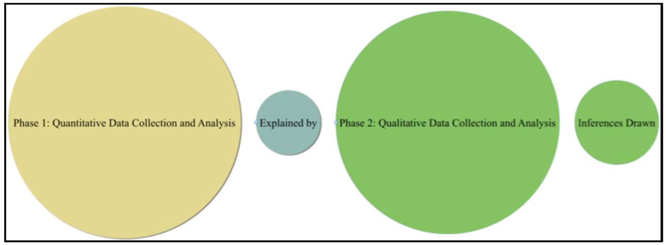

Figure 1. Explanatory sequential design (A Concise Introduction to Mixed Methods Research, John W. Creswell, 2015, p. 39)

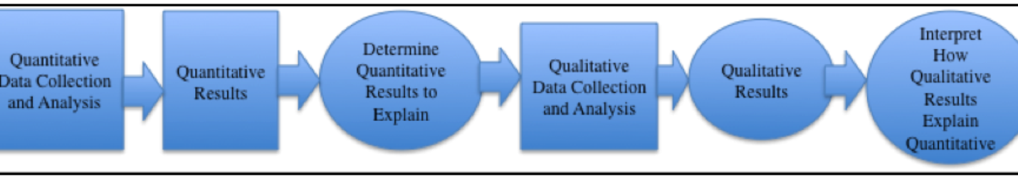

Figure 2. Procedural diagram for explanatory sequential design (A Concise Introduction to Mixed Methods Research, John W. Creswell, 2015, p. 39)

A total of 120 teachers will be sampled through convenience sampling from 300 teachers in the school. The second phase of sampling in the study is the qualitative strand. The individuals in the qualitative sample will be drawn from the pool of participants in the quantitative sample, and because qualitative sample is a subset of the quantitative sample, besides, the qualitative data collection consists of obtaining information from fewer participants than the qualitative sample, the sizes of the two samples will be unequal (Creswell, 2014). A total of 30 teachers were invited to join in the qualitative part of the research; all of them filled the questionnaire in the first phase, so they could understand the interview questions later.

2.2 Teacher teaching and learning questionnaire
The quantitative questionnaire employed for the teachers was adapted from the Organisation for Economic Co-operation and Development (OECD), Teaching and Learning International Survey (TALIS), which is the first international survey to focus on the working conditions of teachers and learning environment in schools. It is worthy to mention that Malaysia has participated in the first round of TALIS as a partner country in 2007-08 (Creating effective teaching and learning environments: First results from TALIS, 2008).
The focus group interviews included audio recordings, these recordings were then transcribed and analysis began upon completion of each transcription. Passages extracted from interviews were taken verbatim from transcriptions of recorded interviews. The data would be coded using both Microsoft Word and NVivo.11 software. (Marshall & Rossman, 1999; Miles &Huberman, 1999; Strauss & Corbin, 1998). A pilot study is employed and the data collected from the pilot test yield a good reliability coefficient at .899. Internal validity was employed at this stage due to the small sample size and a panel of experts helped to validate the questionnaire for content validation. The Exploratory Factor Analysis (EFA) was employed to define the underlying structure among the variables in the analysis.

Table 1. Research questions and data source and collection methods
Main Research questions | Dimensions | Data sources and collection methods
What is the teachers’ perceived value on teacher appraisal? | The objectives of these evaluation  Frequency of assessment  Impact of teacher assessment | Teacher Teaching and Learning Questionnaire  (118 participants)  Open-ended Focus Group Interview  (18 participants)

3. Findings and discussion

3.1 Teacher appraisal and feedback
Evaluation can play an important role in school improvement and teacher development. Identifying strengths and weakness, making informed resource allocation decisions, and motivating actors to improve performance can help achieve policy objectives such as school improvement, school accountability and school choice.

What are the teachers’ perceived values of teacher appraisal?

The first section discusses the nature and impact of school evaluation; it focuses on the frequency of evaluation and the objectives of these evaluations.

3.2 The Frequency and Objectives of Evaluation

School evaluation refers to an evaluation of the whole school rather than of individual subjects or Department. Teacher appraisal and feedback occurs when the school Principal, and external inspector or the teacher’s colleagues review a teacher’s work. This appraisal can be conducted in ways ranging from a more formal, objective approach to a more informal and subjective approach. Exploratory Factor Analysis (EFA) techniques was employed at the beginning and used to sketch the full picture of factor loadings.

KMO and Bartlett's Test
Kaiser-Meyer-Olkin Measure of Sampling Adequacy. |  | .855
Bartlett's Test of Sphericity | Approx. Chi-Square | 1497.038
 | df | 190
 | Sig. | .000

Table 2. Exploratory Factor Analysis (The areas of teacher appraisal and evaluation)

Pattern Matrixª | Component
 | 1 | 2 | 3 | 4
Direct appraisal of my classroom teaching. | .871
Innovative teaching practices. | .830
Relations with students. | .817
Professional development I have undertaken. | .801
Classroom management. | .743
Knowledge and understanding of my main subject field(s). | .741
Knowledge and understanding of instructional practices, knowledge in my main subject field(s). | .686
Student discipline and behaviour. | .677
Other student learning outcomes. |  | .875
Student feedback on my teaching. |  | .861
How well I work with the Principal and my colleagues. |  | .823
Teaching students with special learning needs. |  | .783
Teaching in a multicultural setting. |  | .779
Extra-curricular activities with students (e.g. school plays and performances, sporting activities). |  | .760
Principal. |  |  | .893
Other teachers or members of the school management team. |  |  | .810
Student test scores. |  |  |  | .907
Retention and pass rates of students. |  |  |  | .904
Feedback from parents. |  |  |  | .420

Table 3. Reliability Result (The areas of teacher appraisal and feedback)
Cronbach’s alpha | N of Items
.915 | 8
.911 | 6
.700 | 2
.826 | 3

Table 4. Mean value (The areas of teacher appraisal and feedback)
Factor | Mean | Mean  Midpoint | Value  Minimum | Maximum
1. Teacher teaching practices | 32.45 | 24 | 8 | 40
2. Enhanced teaching activities/  Cooperation with Principal or  teachers | 21.48 | 18 | 6 | 30
3. Evaluation parties | 4.96 | 8 | 2 | 14
4. Student achievement and  feedback from parent | 11.34 | 9 | 3 | 15

Factor loadings in this section (Table 4) has four streams; assessment focus include factor one “Teacher teaching practices”, factor two “Enhanced teaching activities/Cooperation with Principal or teachers” and factor four “Student achievement and feedback from parent” while, factor three refers to “the assessment parties for the school”. According to the comparison between mean value and midpoint, factor one “Teacher teaching practices” (mean 32.5, midpoint 24) is higher than the others, the maximum value is 40, the mean value of factor one is 32.5, which means that teachers think teacher teaching practice is moderate and of quite high importance when they receive this appraisal and feedback. The enhanced teaching activities or cooperation with Principal or teachers (mean 21.5, midpoint 18) is also considered with moderate and higher importance. Then is the student achievement and feedback from parent (mean 11.34, midpoint 9).

It is interesting to note that the frequency of appraisal and feedback they received from Principal, other teachers, members of the school management team and external individuals or bodies were not as frequent as they expected (mean 4.96, midpoint 8). The frequency is between once every two years and once a year and some teachers in the focus group interviews indicated that the evaluation work could be organized at least twice per year for the fair and correct result.
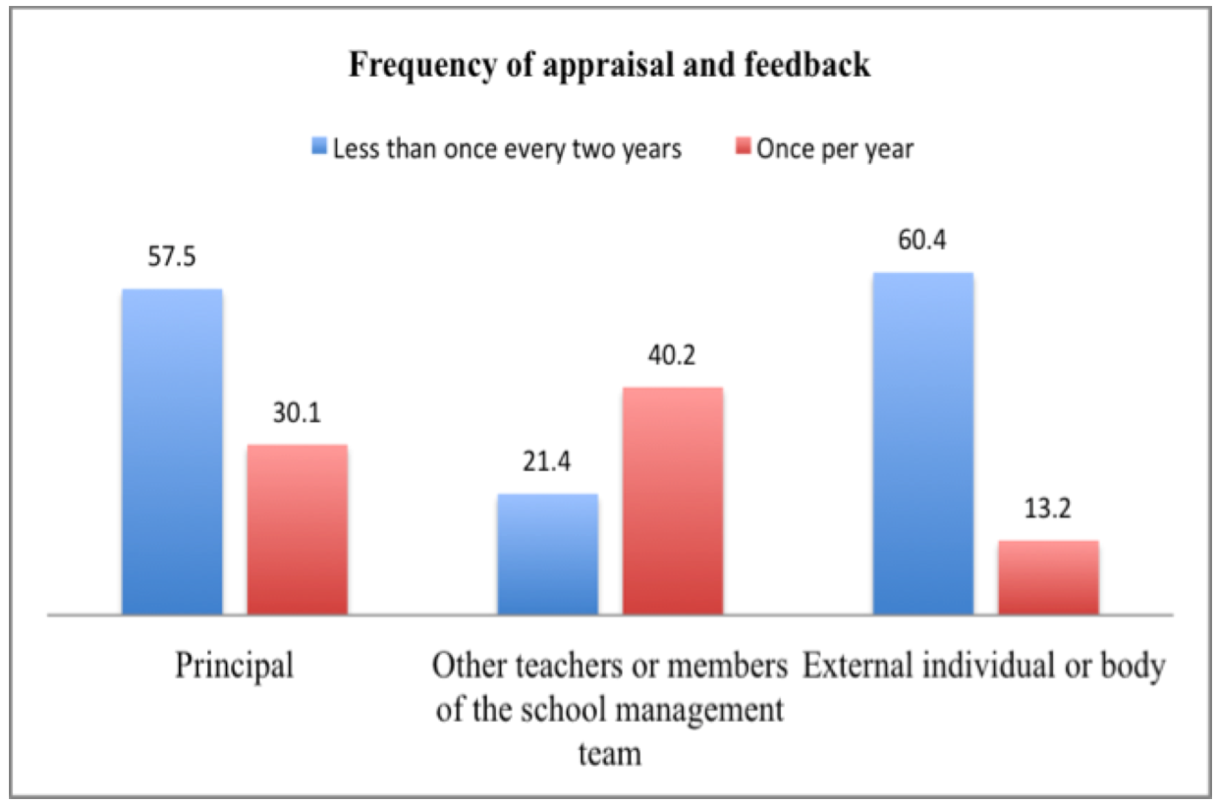
Figure 3. Frequency of appraisal and feedback

In terms of teacher appraisal and feedback frequency (Figure 3), about half of teachers (57.5%) reported that the frequency of receiving appraisal and feedback from the Principal is less than once every two years and some of them (30%) said that it is about once per year. Some teachers (40.2%) reported that the appraisal and feedback that they had received from other teachers or members of the school management was about once per year. Teachers (60.4%) reported that the rate of receiving the appraisal and feedback from the external individual or body was less than once every two years. School evaluation conducted by an external inspectorate or equivalent agency was slightly less frequent than school self-evaluations during the study period. This indicated that the evaluation system of this school is more internally driven. In a conclusion, appraisal and feedback from other teachers or members of school management team was higher than Principal assessment or the external parties.

3.3 Focus of Teacher Appraisal Criteria

Teachers were asked to rate the importance of 17 potentially important areas in evaluations undertaken in the previous one year, given that these areas would generally be considered important for students’ education (Figure 4).

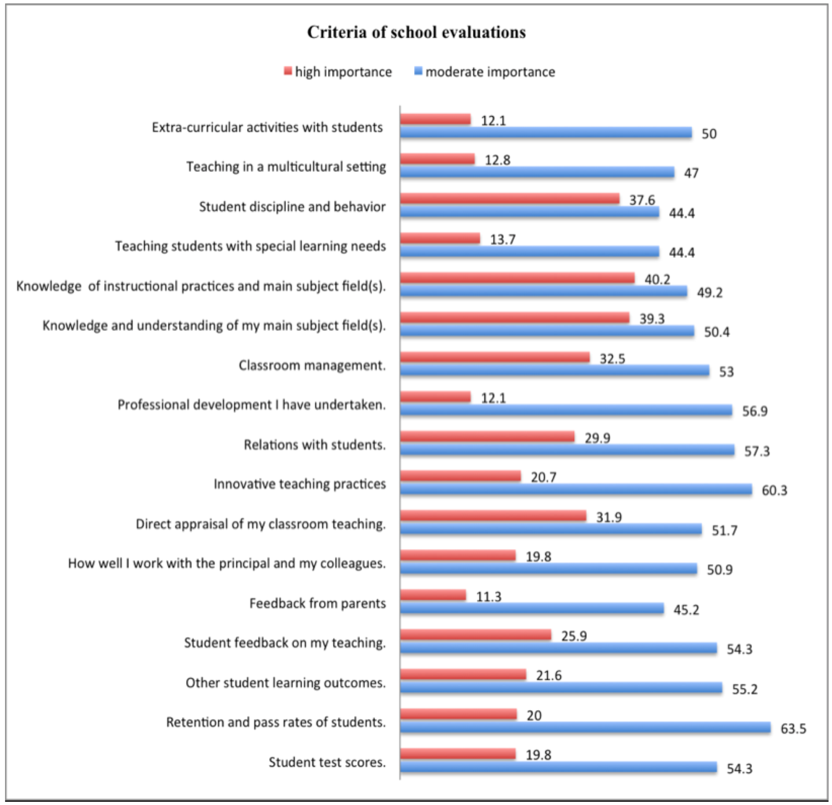
Figure 4. Criteria for school evaluations

Figure 4 distinguishes between two categories of school evaluation in the school, teaching activities and student outcomes. Regarding with student outcomes, there are three main criteria: Student test score (54.3%), retention and pass rates (63.5%), and a category described as other learning outcomes (55.2%). Interestingly, comparing student outcome criteria, retention and pass rates of students were the most important while the students’ test score is the lowest among the student outcome criteria.

Comparing the other five related criteria, feedback from parents (45.2%) was considered to be of somewhat relatively low importance according to teachers’ report in this school, while student feedback about the teaching they received (54.3%) was rated as of relatively high importance in the school. It is proved from another criteria that relations with students (57.3%) rated relatively high as of moderate importance in school evaluation, finally, extra-curricula activities with students is also an important criteria perceived by teachers (50%). However, teachers think teaching students with special learning needs (44.4%) is not very important as a school evaluation criteria as well as student discipline and behaviour (44.4%).

The highest rated criteria for teaching activities in this school in order of moderate importance were: Innovative teaching practice (60.3%), professional development teacher has undertaken (56.9%), classroom management (53%), direct appraisal of teachers’ classroom teaching (51.7%), how well they work with the Principal and colleagues (50.9%), knowledge and understanding of main subject fields (50.4%), and knowledge of instructional practice (49.2%).

Central to teachers’ ability to educate students is their knowledge of their main subject fields (39.3%) and instructional practice (40.2%). These were considered to be of high importance in school evaluations. However, teaching in a multicultural setting (12.8%) was relatively lower rated criteria for school evaluation. The relatively minor focus on teaching in a multicultural setting in school evaluation may not be a problem in this school as teachers did not report the need for improvements in their teaching in multicultural setting which is the lowest rated as the most needed professional development area. This finding is different from the OECD survey result as reported in the following:
“In contrast, in Malaysia over three-quarters of teachers who reported a high level of development need in this area worked in schools that gave teaching in a multicultural setting moderate or high importance in their school evaluation.”
(Creating Effective Teaching and Learning Environments: First Results from TALIS, OECD, 2009, p. 146)

The majority of students of The Independent High School are local Chinese, however, as the proportion of Non-Chinese students has kept increasing during these years, the multicultural setting would be more and more important in the future.

3.4 Outcome of Teacher Appraisal and Feedback

What are the teachers’ perceived outcome of appraisal and feedback?

To better understand the role of school evaluation within the larger framework for evaluating education in schools, teachers were asked to identify the level of influence of school evaluations. If school evaluations are to have an impact on school Principals and teachers, and ultimately on student learning, they will have to have an effect on the functioning of schools and potentially on the development of schoolteachers. The greater the potential impact of a school evaluation the greater the potential impact on the education offered by schools.

Table 5. Exploratory Factor Analysis (Changes led by the appraisal or feedback received at this school)
(KMO and Bartlett's Test)
Kaiser-Meyer-Olkin Measure of Sampling Adequacy. |  | .917
Bartlett's Test of Sphericity | Approx. Chi-Square | 1740.470
 | df | 105
 | Sig. | .000

Pattern Matrixa
 | Component
 | 1 | 2
A change in salary. |  | .938
A financial bonus or another kind of monetary reward. |  | .957
Opportunities for professional development activities. |  | .609
A chance in the likelihood of career advancement.  Public recognition from the Principal and/or your colleagues.  Public recognition from the Principal and/or your colleagues. |  | .628
Changes in your work responsibilities that make the job more attractive. |  | .778
A change in salary. |  | .636
A financial bonus or another kind of monetary reward. |  | .712
Your classroom management practices. | .831
Your knowledge and understanding of your main subject field(s). | .999
Your knowledge and understanding of instructional practices (knowledge mediation) in you main subject field(s). | 1.002
A development or training plan to improve your teaching. | .882
Your teaching of students with special learning needs. | .638
Your handling of student discipline and behaviour problems. | .892
Your teaching of students in a multicultural setting. | .543
The emphasis you place upon improving student test scores in your teaching. | .774
Extraction Method: Principal Component Analysis.
Rotation Method: Oblimin with Kaiser Normalization.ª
a. Rotation converged in 7 iterations.

Table 6. Reliability result (Changes led by the appraisal or feedback

received in the school)
Reliability  Crobach’s alpha | N of Items
.927 | 7
.949 | 8

Table 7. Mean value (Changes led by the appraisal or feedback received in the school)
Factor | Mean | Midpoint | Minimum | Maximum
1. Changes on working conditions  (Financial rewards / Public  recognition / work  responsibility) | 15.09 | 17.5 | 7 | 28
2. Changes on teaching activities | 20.64 | 20 | 8 | 32

The Exploratory Factor Analysis (EFA) (Table 5) gives the factor loadings condition of this section; the value of KMO .917 is very high enough to provide valid construct evidence. According to the mean value result (Table 7), the mean value of “Changes on working conditions” (15.09) is lower than the midpoint of 17.5; for these appraisals teacher received at this school led to a small change on the working conditions. On the other hand, “Changes on teaching activities” (20.64) is higher than the midpoint 20. For this factor, the feedback and appraisal teachers received have directly led to a moderate change on teaching activities with a limited degree.
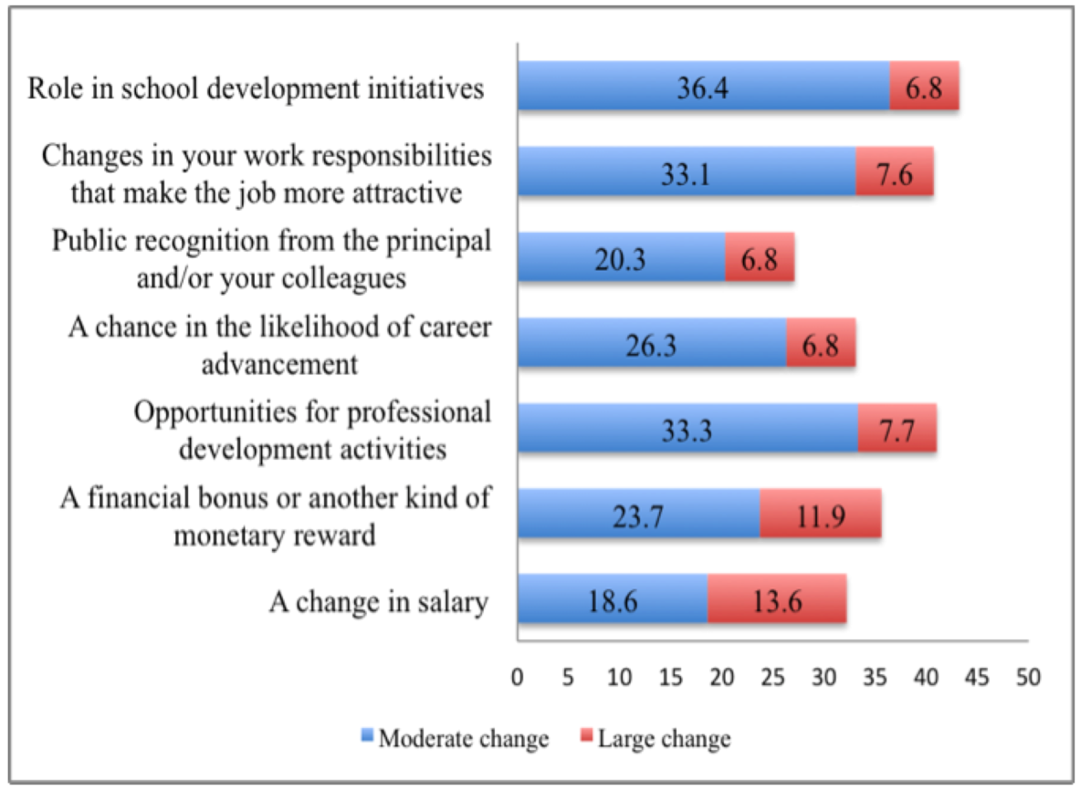

Figure 5. Changes led by received appraisal from the school

Teachers (43.2%) indicated that the teacher assessment result would change their ’role in the school development initiatives, and it would give them opportunities to take part in professional development activities (41%). Some teachers (40.7%) think it also bring some certain changes in their work responsibilities (40.7%). However, only a small group teachers (35.6%) said they would get a financial bonus or another kind of monetary reward, salary raise (32.2%) or career advancement (33.1%). Finally, there is no obvious change in public recognition from the Principal as only polled by 27.1% of teachers (Figure 5).

3.5 Impact of Appraisal and Feedback on Teachers’ Performance

What are the teachers’ perceived impact of appraisal and feedback?

The following section is the discussion of the impact of appraisal and feedback on teaching and teacher’s work. Seven specific outcomes that affect teachers and their work are discussed in this section; it includes several dimensions such as teachers’ job satisfaction, effect on their teaching, and broader school development.

Table 8. Exploratory Factor Analysis (Teachers’ perceived value of appraisal and feedback received in the school)

KMO and Bartlett's Test
Kaiser-Meyer-Olkin Measure of Sampling Adequacy. |  | .811
Bartlett's Test of Sphericity | Approx. Chi-Square | 798.316
 | df | 66
 | Sig. | .000

Pattern Matrixa
 | Component
 | 1 | 2 | 3
In my opinion, in this school the Principal takes steps to alter  the monetary rewards of a persistently underperforming teacher. | .934
In this school, teachers will be dismissed because of sustained  poor performance. | .899
In my opinion, in this school a development or training plan  is established for teachers to improve their work as a teacher. | .871
In my opinion, the most effective teachers in this school receive  the greatest monetary or non- monetary rewards. | .841
If I improve the quality of my teaching at this school, I will  receive increased monetary or non- monetary rewards. | .630
If I am more innovative in my teaching at this school, I will  receive increased monetary or non- monetary rewards. | .447
In my opinion, the review of teachers’ work has little impact  upon the way teachers teach in the classroom in this school. |  | .883
In my opinion, the rest of the staff in this school would tolerate  the sustained poor performance of a teacher. |  | .846
I think the appraisal of my work and /or feedback received was  a fair assessment of my work as a teacher in this school. |  |  | .934
I think the appraisal of my work and /or feedback received was helpful in the development of my work as a teacher in this school. |  |  | .913
In my opinion, the review of teachers’ work is largely done to fulfill administrative requirements in this school |  |  | .572
In my opinion, in this school the Principal uses effective methods  to determine whether teachers are performing well or badly. | .422 |  | .506
Extraction Method: Principal Component Analysis.
Rotation Method: Oblimin with Kaiser Normalization.
a. Rotation converged in 6 iterations.

Table 9. Reliability result (Teachers’ perceived value of appraisal and feedback received in the school)
Reliability  Cronbach’s alpha | N of Items
.909 | 6
.581 | 2
.844 | 4

Table 10. Mean value (Teachers’ perceived value of appraisal or feedback received in the school)
Factor | Mean | Midpoint |  | Minimum | Maximum
1. School’s rewards or punishment on  teachers’ teaching practices | 14.88 |  | 15 | 6 | 24
2. Influence on teaching practice/  Attitude towards sustained poor  performance teacher | 5.53 |  | 5 | 2 | 8
3. The fairness and effectiveness of  teacher assessment in the school | 9.96 |  | 10 | 4 | 16

Table 8 gives the factor loadings condition of this section

The difference between mean and midpoint of each factors indicated that there is a space for School Governing Board to improve the effectiveness of teacher assessment work in the school. Table 10 shows that all the mean value is lower than midpoint and factor two is not higher enough to consider it as good: The factor one “school’s rewards or punishment on teachers teaching practices” (mean 14.88, midpoint 15), factor three “The fairness and effectiveness of teacher assessment” (mean 9.96, midpoint 10), and factor two “Influence on teaching practice / Attitude towards sustained poor performance teacher” (mean 5.53, midpoint 5).

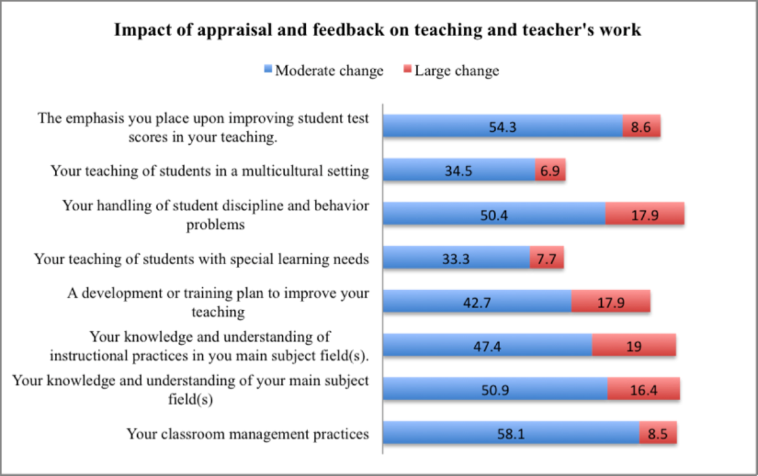

Figure 6. Impact of appraisal and feedback on teachers’ teaching activities

Teachers recognized that their classroom management practice had been moderately changed (58.1%) after they received the appraisal and feedback. Besides, the assessment also changed their emphasis upon students test scores in their teaching (54.3%), and it would affect their knowledge of the main subject field (50.9%). Their handling of student discipline and behaviour problems also would be moderate changed (50.4%). However, not many teachers (47.4%) agree that it would influence their knowledge and understanding of instructional practices in the main fields or their development-training plan (42.7%). Finally, few teachers think their ability of teaching students in a multicultural setting (34.5%) or teaching of students with special learning needs (33.3%) was moderate changed (Figure 6).
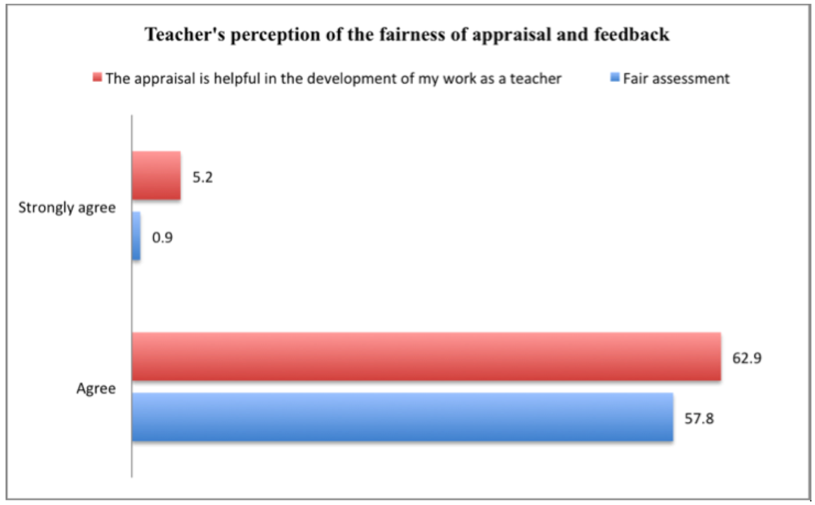Figure 7. The fairness and effectiveness of appraisal and feedback (Views ofteachers)

In terms of fairness (Figure 7), more than half of teachers (57.8%) think that the assessment work was fair with a large proportion (62.9%) indicating that the appraisal was helpful for their work development.

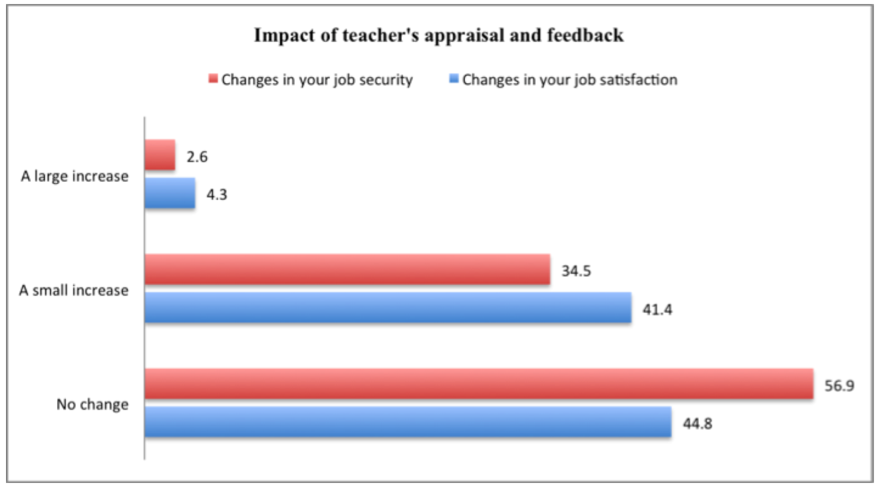Figure 8. The changes in job security and job satisfaction (Views of teachers)

The result (Figure 8) also shed some light as to how the appraisal impacted their job security and job satisfaction. More than half the teachers (56.9%) think thought that the appraisal had no impact on their job security, as well as job satisfaction (44.8%). While, teachers (34.5%) indicated that there are small increase on changes in their job security and changes in their job satisfaction (41.4%). However, only 2.6 and 4.3% of participants stated that there would be a large impact on job satisfaction and security.

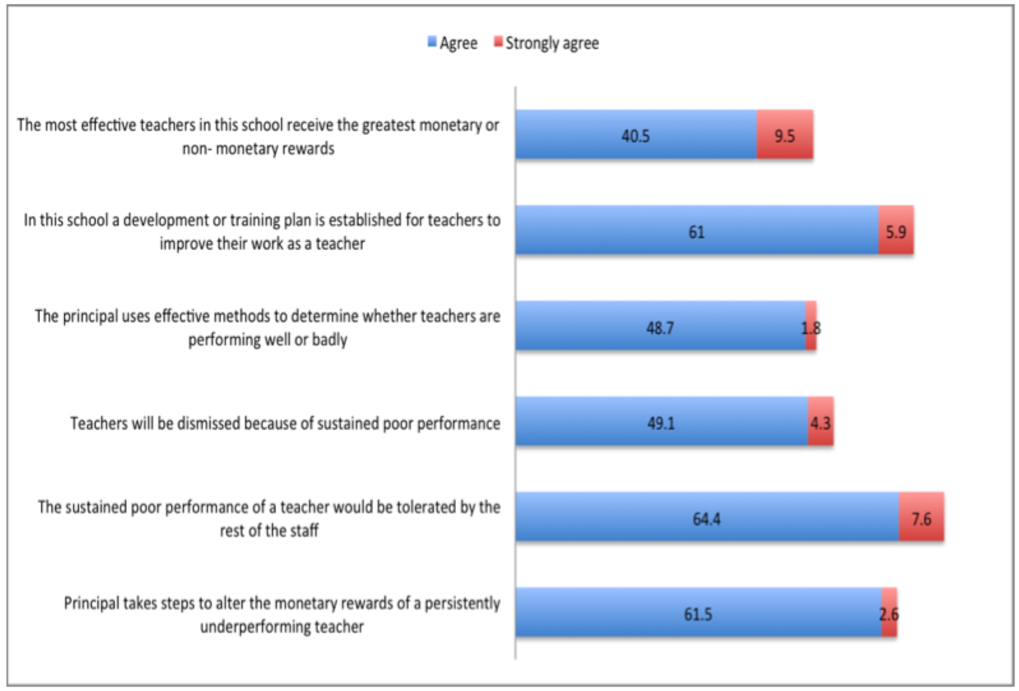Figure 9. Teachers assessment in school development context

Figure 9 presents teachers’ views on the school assessment system and the recognition accorded teachers for their work. It portrayed a positive picture of teachers’ working life and career situation in the school. Most of teachers (61.5%) reported that Principal takes steps to alter the monetary rewards of persistently underperforming teacher, as well as the development of training plans established for teachers to improve their work (61%); however, a large proportion of teachers (64.4%) reported that the sustained poor performance of a teacher would be tolerated by the rest of staff, the reasons would be discussed later. Some teachers (49.1%) agreed that teachers would be dismissed because of sustained poor performance. Besides, some teachers (48.7%) stated that effective methods were utilized to determine whether teachers were performing well or badly and teachers (40.5%) indicated that the most effective teachers in this school receive the greatest monetary or non-monetary rewards.

The findings are reinforced by the fact that a similar proportion of teachers (45.3%) reported that if they improved the quality of teaching, they would receive monetary or non-monetary rewards. Less than half of the teachers (42.2%) expressed that if they are more innovative in their teaching, they will receive increased money or non- money rewards (Figure 10).
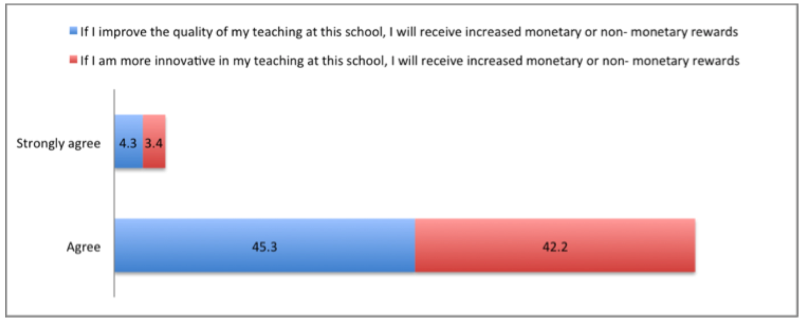

Figure 10. The reward mechanism (Views of teachers)

Teachers give more details about the reasons for tolerating the poor performance of other teachers.
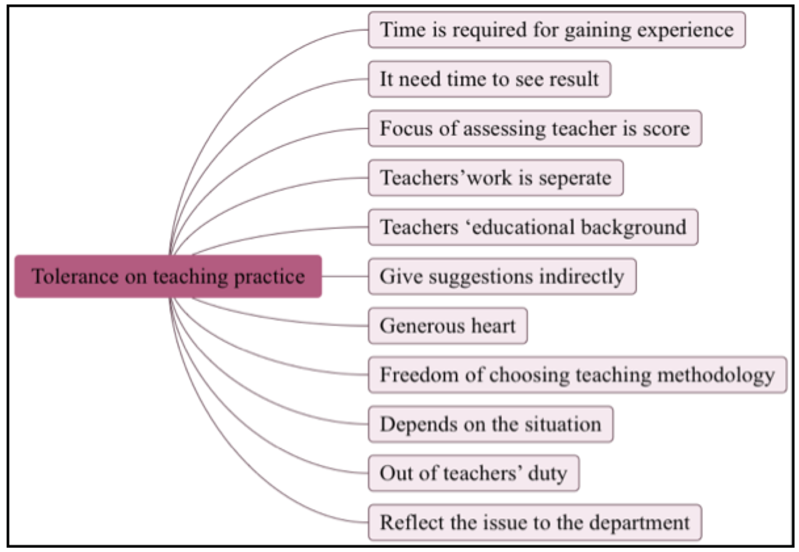
Figure 11. The sustained poor performance of a teacher (Views of teachers)

Teachers indicated that the sustained poor performance of another teacher could be tolerated for the following reasons: In terms of duty, teachers regard this kind of issue as the duty of Director of the Teaching Affairs Department. Some teachers indicated that this problem should be solved by the related Department and that it was beyond their authority. Besides, it was important to respect the cultural difference between Chinese and other ethnic groups and a generous heart is required in the school. One of the interviewees also pointed out that they had brought this kind of issue to the administrative board, but no changes resulted. This made teachers feel this kind of problem could not be solved, so they preferred to concentrate on their own teaching work. In terms of qualifications, a large proportion of teachers in the school did not have a Bachelor’s degree in Education therefore needed time and practice to enhance and improve personal teaching skills gradually over time.

Besides, teachers regarded teaching methodologies as a subjective issue and that each teacher had the freedom to choose the instructional methods that would be most effective in class. Teachers were more concerned about their own sphere of teaching and not concerned with the methods other teachers employed in their classrooms. Teaching methods varied from classroom to classroom, was largely subjective and based on individual teaching experience and personal judgment. Thus, they were wary of intervening in their colleague’s sphere of work even on the grounds of poor performance because it had no direct relation with their own teaching practice.

However, a few teachers expressed a different opinion; they thought that teachers worked as a group, so that the poor performance of one will influence the others. This issue deserves concern, so they would give suggestions and experience indirectly. A proportion of teachers also mentioned that certain serious issues would be brought the governing board’s attention. For instance, disciplinary type issues which raise concerns about a teacher’s moral development. One teacher asserted that the problems of teaching practice could be tolerated, but the sustained poor performance of the administrative board cannot be neglected.

Charmaine
I think because in the Chinese community, we are not accustomed to public criticism of the poor performance of others, and is usually our teacher's work is separate Well, basically you teach your class, I taught my class, that Since you teach your class will not have any impact on me, then I certainly do not have any strong rebound.

P1.1
This seems to be a personal, will not affect, as if his poor performance is his personal thing.

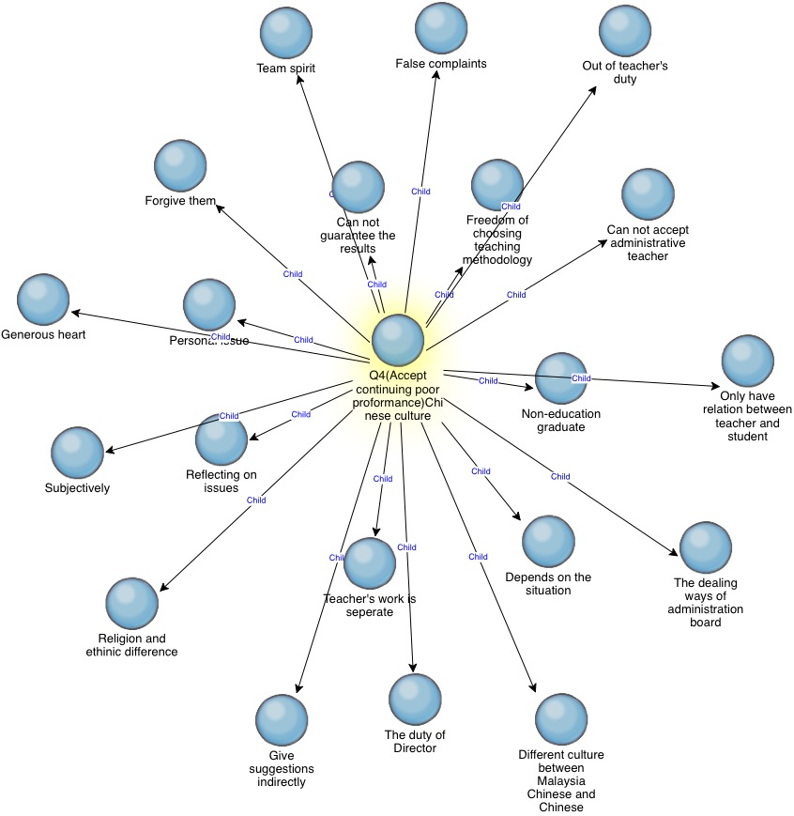

Figure 12. The sustained poor performance of a teacher (Views of teachers)

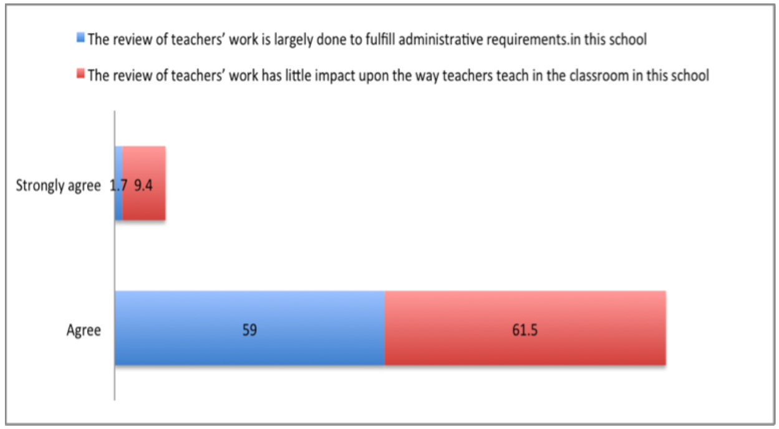
Figure 13. The review of teachers’ work (Views of teachers)

It is worthy to note that a proportion of teachers (59%) think that the review of teachers’ work is largely done to fulfil administrative requirements in the school. Some teachers (61.5%) indicated that the review of teachers’ work has little impact upon the way teachers teach in the classroom (Figure 13).

To summarize, appraisal and feedback has a moderately positive influence on teachers and their work. Teacher agreed that it increases their job satisfaction and, to some degree, their job security, and it significantly increases their development as teachers. Most teachers reported that school evaluation will influence their role in school development initiatives and it will lead to changes in their work responsibilities and job satisfaction.

3.6 Teachers’ Perceived Value of the Assessment and Evaluation work
What are the teachers’ perceived limitation of appraisal and evaluation work done by the school?

In terms of limitation, lack of communication between school board and teachers was regarded as the most important issue of the school assessment mechanism, teachers indicated that the administrative board evaluated teacher’s work and scored the result, then teachers received the score without explanation. Teachers indicated their expectation on further information about the score, for instance, what are the shortcomings, which lead to a low score as well as the teachers’ strengths. They hope to have communication with the related Department, but the follow-up activities on assessment rarely happened in the school. Generally, teachers needed more open communication with members of the governing board; teachers mentioned that a ‘once only’ interaction was not enough to address the issues that the feedback and appraisal process had raised and further checking was needed on whether such issues had been resolved or whether the teachers needed to be supported in resolving such issues.

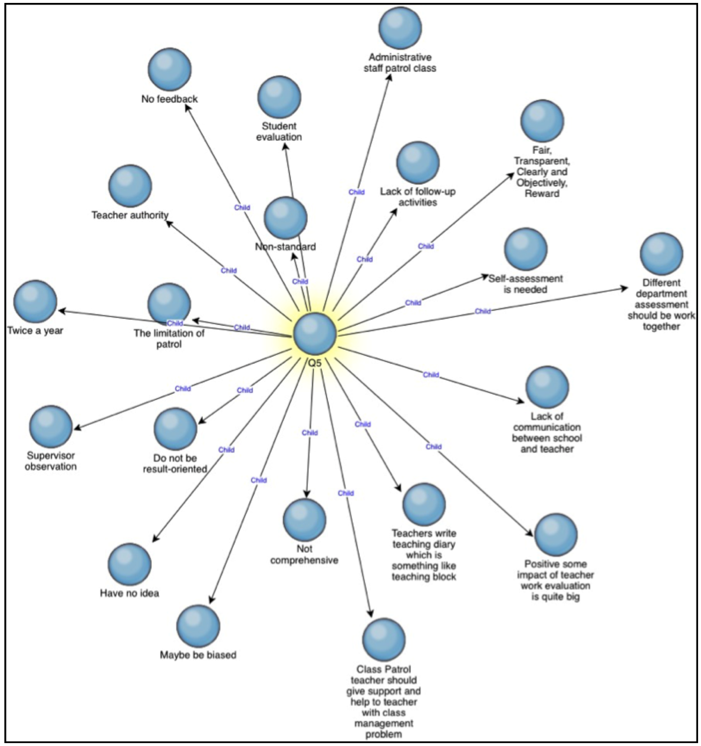
Figure 14. Teachers’ expectations and suggestions for teacher assessment

Teachers give their opinions as follow:
Ho
In fact, in the administrative area, our administration staff will be sent to patrol the class every time. If I am not making an mistake, the inspectors will have a rating on the observation of the situation of those teachers. As for what happened after the patrol we do not know, because we are not that.

Charmaine
If teachers say so, I have thought, in fact, the administrative staff of the tour, they look at just for a minute or two like this, is not accurate, if you say to have a proposal and suggestion, do not give teacher too much pressure. The best time to visit the classroom is to go inside and sit in for a while, but that will make the teacher more pressure, so I do not know how to do.

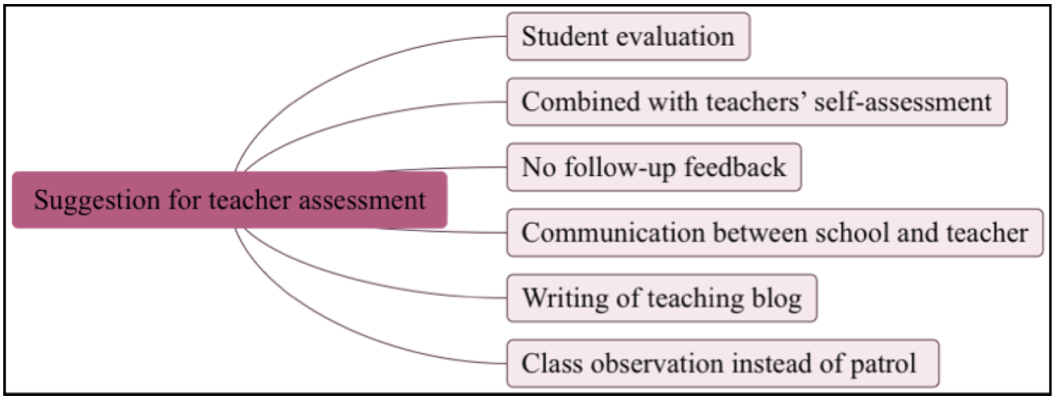
Figure 15. Suggestions for teacher assessment

With reference to the teaching inspector, teachers pointed that the observation for few minutes outside the classroom cannot accurately reflect a comprehensive evaluation result. Teachers hope that the inspectors or Principals could enter the classroom and observe teachers’ teaching practice for a fair and correct assessment outcome. Teachers expressed reservations about this practice; if the inspectors happened to observe students being noisy or unruly at the end of the class period when the students were supposed to be engaged in self-activity or self-reading then the teachers feared that they would be judged poorly on effective classroom management.

Teacher self-evaluation was mentioned as a suggestion to improve the assessment process. Teachers could weigh the quality of their work first. The self-evaluation result should be consistent with the assessment outcome from the school board, and discussed by both parties, if the results are quite different. Teachers also expressed that the assessment could be done twice a year. A more frequent process was good for checking whether the teacher made progress or not. Communication and feedback about the evaluation results was very necessary and important for improvement and correction. All in all, the core of the assessment work should be transparent, clear and objective and teachers considered the evaluation work done annually to have an impact on their development generally.

4. Conclusion and Discussion
Teacher appraisal is important to increase teachers’ job satisfaction and teaching practice and these factors will impact school quality and school reputation. Teachers play various roles in a school so that the multiple layer assessment was employed for teacher appraisal work in the school. Teachers perceived these internal assessments as ineffectual but nevertheless necessary to fulfil the school’s administrative requirement.
The assessments had little impact on teachers’ role in the school. Teachers reflected that there was little change in public recognition from the Principal or colleagues, career advancement prospects or salary increments after the assessment. These three aspects are undeniably important to the enhancement of teachers’ satisfaction. Some teachers were glad to be informed of their areas of weakness but perceived these assessments as inadequate because it was only conducted once a year. They suggested that an appraisal system on a bi-annual basis would yield more accurate results on their performance and classroom teaching methods. Teachers also suggested the incorporation of a self-assessment component into the current system for a more accurate reflection of the school assessment outcome.
Teachers also suggested that classroom observation should replace the current practice of patrolling school corridors by the assessing party. The latter practice has been deemed as largely ineffective; for instance, the few minutes the assessing party spends on observing teaching practice outside the door is not enough. It would be hard to produce an accurate or comprehensive appraisal during that limited time. The head teacher should be actively engaged in classroom observation. Last but not least teachers could maintain a teaching blog, distinct from the lesson plan that could be used for the better understanding of teaching practices.
One of the primary purposes of formal performance appraisals is to provide clear, performance-based feedback to employees (Carroll & Schneier, 1982). Feedback should be relevant, timely, factual, helpful, confidential, respectful, tailored to specific needs and encouraging. Teachers that receive relevant information concerning their performance or achievements are more likely to be successful as they engage in the teaching- learning process. Thus, it is important for the feedback process to have these features:

Relevant, addresses student and teacher-specific learning and teaching performance, respectively, in addition to achievements, needs and interests;
Immediate, provided as soon as information about teacher performance is available;
Factual, based on actual student achievement (performance on a test, assignment or project) and teacher’s instructional performance and assessment;
Helpful, provides suggestions for improvement of teaching and learning;
Confidential, given directly to teacher without an intermediary;
Respectful, respects students’ and teachers’ integrity and needs;
Tailored, designed to meet individual students’ or teachers’ specific needs and circumstances;
Encouraging, motivates teacher to continue and to increase teaching and learning efforts.
(Ovando, 1994)

Acknowledgements
This thesis could not have been finished without the guidance and encouragement of Professor Dr Mogana Dhamotharan. I greatly appreciate all you have done to guide me through this process. Then, I would like to thank the China Scholarship Council and Embassy of China in Malaysia for supporting my study in Malaysia.
Special thanks go to Dr Palani Veloo and Dr See Hoon Peow who provided helpful insights and suggestions that have strengthened my thesis. I would also like to thank Ms Koh Lei Ming of The Independent High School, who provided valuable assistance regarding data collection. Many thanks to Ms Cheong Moey Lian, Ms Chan Yoke Lee and Mr Lee Sui Ang, the three Vice-Principals as well as teachers, students and parents of The Independent High School for spending their time to take part in this lengthy process. Additionally, I would like to thank Ms. Sumita Lee for her kind and valuable help in editing. I also would like to thank Mr Loh Kuo Hao, the administrator of the Confucius Institution of SEGi University for his kind and valuable help in translating excerpts and information from Bahasa Malaysia to Mandarin. I would like to thank my parents and friends for their encouragement during this process.
Time is valuable to all of us, yet many individuals have been generous with their time and knowledge. Ms Lydia Foong, Ms Priya Vijayan and Dr Chong Wei Ying each had their own reassuring words to help alleviate my concerns. I am grateful to every person who has accompanied me on my journal to obtain a doctorate. I am sincerely grateful to all these individuals. I too will try my best to support and help others in the same way you all have helped me.

References
Carroll, Stephan J. and Craig E. Schneier. (1982), Performance Appraisal and Review Systems: The Identification, Measurement and Development of Performance in Organizations. Glenview, IL: Scott, Foresman.
Comber, L. (1983). 13 May 1969: A historical Survey of Sino-Malay Relationship, Kuala Lumpur: Heinemann Asia.
Creswell, J. W., 2014. Research design: qualitative, quantitative, and mixed methods approaches 4th ed., California: SAGE.
Creswell, J.W., 2015. A Concise Introduction to Mixed Methods Research, University of Nebraska-Lincoln, United States of America: SAGE.
Kua, K. S., 1990. A Protean SAGA: THe Chinese Schools of Malaysia, Pencetakan Dan Perniagaan Berlian Sdn Bhd.
Lee, T.H., 2011. Chinese Schools in Peninsular Malaysia: The Struggle for Survival, Singapore: Institute of Southeast Asian Studies.
Marshall, C., & Rossman, G. B. (1999). Designing qualitative research (3rd ed.). Thousand Oaks, CA: Sage.
Miles, Matthew B., & Huberman, A. Michael. (1994). Qualitative data analysis (2nd ed.). Thousand Oaks, CA: Sage.
Ovando, M. N. (1994). Constructive Feedback: A Key to Successful Teaching and Learning. International Journal of Educational Management, 8(6), 19–22. http://doi.org/10.1108/09513549410069185
OECD, 2006. Teachers Matter: Attracting, Developing and Retaining Effective Teachers, Available at: http://www.oecd-ilibrary.org/education/teachers-matter_9789264022157-ja.
OECD, 2013. TALIS 2013 Results: An International Perspective on Teaching and Learning, Available at: http://dx.doi.org/10.1787/9789264196261-en.
R.Santhiram & Tan Yao Sua, 2010. The Education of Ethnic Minorities, Strategic Information and Research Development Centre (SIRD). Available at: www.gerakbudaya.com.
School Year Book (2015). The Independent High School
Strauss, A., & Corbin, J. (1998). Basics of qualitative research: Procedures and techniques for developing grounded theory (2nd ed. Vol.). Thousand Oaks, CA: Sage.

